**HIGH PERFORMANCE**

**COMPUTING**

**SEMESTER 6, 2023**



**Name - Akhil Dubey**

**Roll - 2020UCO1673**

**Branch - COE 3**

**Submitted To:**

**Experiments**

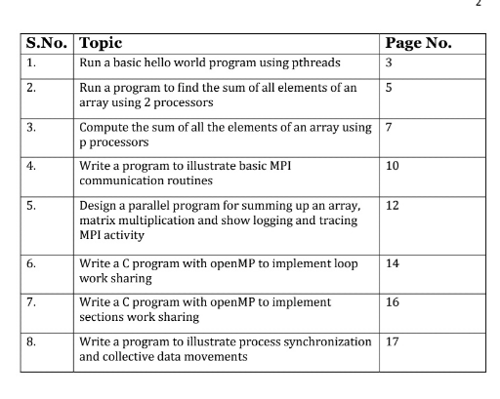

**Experiment 1**

**Run a basic hello World program using pthreads**

#include <pthread.h>

#include <stdio.h>

#include <stdlib.h>

#define NUM_THREADS 3

void *PrintHello(void *threadid)

{

    long tid;

    tid = (long)threadid;

    printf("Hello World! Thread #%ld!\n", tid);

    pthread_exit(NULL);

}

int main(int argc, char *argv[])

{

    pthread_t threads[NUM_THREADS];

    int rc;

    long t;

    for (t = 0; t < NUM_THREADS; t++)

    {

        rc = pthread_create(&threads[t], NULL, PrintHello, (void *)t);

        if (rc)

        {

            printf("ERROR; return code from pthread_create() is %d\n", rc);

            exit(-1);

        }

    }

    /* Last thing that main() should do */

    pthread_exit(NULL);

}

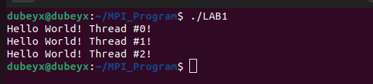

**Experiment 2**

**Find the sum of all elements of an array using two processors using pThreads**

#include <stdio.h>

#include <stdlib.h>

#include <pthread.h>

#define ARRAY_SIZE 10 // size of the array

#define NUM_THREADS 2 // number of threads

int array[ARRAY_SIZE];             // the array to sum

int partial_sums[NUM_THREADS];     // partial sums for each thread

pthread_mutex_t lock;             // mutex for accessing partial_sums

// thread function to compute partial sum

void *partial_sum(void *thread_id)

{

    int id = *(int *)thread_id;

    int start = id * (ARRAY_SIZE / NUM_THREADS);

    int end = (id + 1) * (ARRAY_SIZE / NUM_THREADS);

    int sum = 0;

    for (int i = start; i < end; i++)

    {

        sum += array[i];

    }

    pthread_mutex_lock(&lock);

    partial_sums[id] = sum;

    pthread_mutex_unlock(&lock);

    pthread_exit(NULL);

}

int main()

{

    int n;

    printf("Enter size of array <10: ");

    scanf("%d", &n);

    for (int i = 0; i < n; i++)

    {

        scanf("%d", &array[i]);

    }

    // initialize the mutex

    pthread_mutex_init(&lock, NULL);

    pthread_t threads[NUM_THREADS];

    int thread_ids[NUM_THREADS];

    // create the threads

    for (int i = 0; i < NUM_THREADS; i++)

    {

        thread_ids[i] = i;

        pthread_create(&threads[i], NULL, partial_sum, (void *)&thread_ids[i]);

    }

    // join the threads

    for (int i = 0; i < NUM_THREADS; i++)

    {

        pthread_join(threads[i], NULL);

    }

    // compute the final sum

    int sum = 0;

    for (int i = 0; i < NUM_THREADS; i++)

    {

        sum += partial_sums[i];

    }

    // print the final sum

    printf("Sum: %d\n", sum);

    // destroy the mutex

    pthread_mutex_destroy(&lock);

    return 0;

}

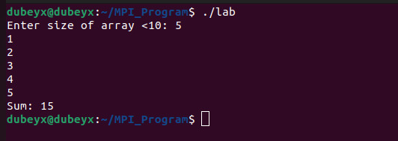

**Experiment 3**

**Find sum of all elements using p processors by using pthreads**

#include <stdio.h>

#include <stdlib.h>

#include <pthread.h>

#include <unistd.h>

#define ARRAY_SIZE 10 // size of the array

int array[ARRAY_SIZE]; // the array to sum

int sum_global = 0; // global variable to store the sum

pthread_mutex_t lock; // mutex for accessing sum

int pthread_num; // global variable to store number of pthreads

pthread_once_t once_control = PTHREAD_ONCE_INIT; // control variable for pthread_once

// function to initialize pthread_num using sysconf

void initialize_pthread_num() {

    pthread_num = sysconf(_SC_NPROCESSORS_ONLN);

}

// thread function to compute partial sum

void *partial_sum(void *thread_id) {

    int id = *(int *)thread_id;

    int start = id * (ARRAY_SIZE / pthread_num);

    int end = (id + 1) * (ARRAY_SIZE / pthread_num);

    int sum = 0;

    for (int i = start; i < end; i++) {

        sum += array[i];

    }

    pthread_mutex_lock(&lock);

    sum_global += sum;

    pthread_mutex_unlock(&lock);

    pthread_exit(NULL);

}

int main() {

    // initialize the array with random values

    int n;

    printf("Enter size of array <10: ");

    scanf("%d", &n);

    for (int i = 0; i < n; i++) {

        scanf("%d", &array[i]);

    }

    // initialize the mutex

    pthread_mutex_init(&lock, NULL);

    // initialize pthread_num using pthread_once

    pthread_once(&once_control, initialize_pthread_num);

    // prompt user for number of pthreads to use

    printf("Enter number of pthreads to use (1-%d): ", pthread_num);

    scanf("%d", &pthread_num);

    if (pthread_num < 1 || pthread_num > pthread_num) {

        printf("Invalid number of pthreads\n");

        return 1;

    }

    pthread_t threads[pthread_num];

    int thread_ids[pthread_num];

    // create the threads

    for (int i = 0; i < pthread_num; i++) {

        thread_ids[i] = i;

        pthread_create(&threads[i], NULL, partial_sum, (void *)&thread_ids[i]);

    }

    // join the threads

    for (int i = 0; i < pthread_num; i++) {

        pthread_join(threads[i], NULL);

    }

    // print the final sum

    printf("Sum: %d\n", sum_global);

    // destroy the mutex

    pthread_mutex_destroy(&lock);

    return 0;

}

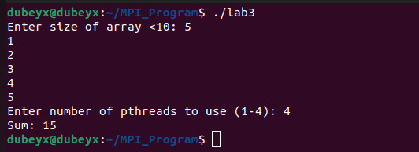

**Experiment 4**

**Illustrate basic mpi communication routines**

#include <stdio.h>

#include <mpi.h>

int main(int argc, char *argv[]) {

    int rank, size, data;

    MPI_Status status;

    MPI_Init(&argc, &argv);

    MPI_Comm_rank(MPI_COMM_WORLD, &rank);

    MPI_Comm_size(MPI_COMM_WORLD, &size);

    // Send and receive data

    if (rank == 0) {

        data = 123;

        MPI_Send(&data, 1, MPI_INT, 1, 0, MPI_COMM_WORLD);

        printf("Process %d sent data %d to process 1\n", rank, data);

        MPI_Recv(&data, 1, MPI_INT, 1, 0, MPI_COMM_WORLD, &status);

        printf("Process %d received data %d from process 1\n", rank, data);

    } else if (rank == 1) {

        MPI_Recv(&data, 1, MPI_INT, 0, 0, MPI_COMM_WORLD, &status);

        printf("Process %d received data %d from process 0\n", rank, data);

        data = 456;

        MPI_Send(&data, 1, MPI_INT, 0, 0, MPI_COMM_WORLD);

        printf("Process %d sent data %d to process 0\n", rank, data);

    }

    // Barrier

    MPI_Barrier(MPI_COMM_WORLD);

    printf("Process %d passed the barrier\n", rank);

    // Finalize

    MPI_Finalize();

    printf("Process %d finalized\n", rank);

    return 0;

}

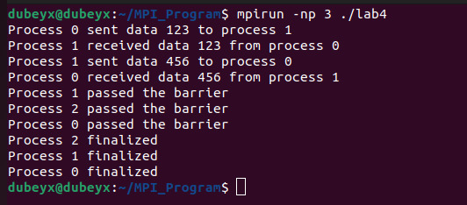

**Experiment 5**

**Design a parallel program for summing up an array, matrix multiplication and show logging and tracing mpi activity**

#include <mpi.h>

#include <stdio.h>

#include <stdlib.h>

#define ARRAY_SIZE 100000

#define MATRIX_SIZE 1000

int main(int argc, char **argv) {

int rank, size;

int array[ARRAY_SIZE], sum = 0;

int matrix[MATRIX_SIZE][MATRIX_SIZE], result[MATRIX_SIZE][MATRIX_SIZE];

int i, j, k;

MPI_Init(&argc, &argv);

MPI_Comm_rank(MPI_COMM_WORLD, &rank);

MPI_Comm_size(MPI_COMM_WORLD, &size);

// Initialize array

for (i = 0; i < ARRAY_SIZE; i++) {

array[i] = i;

}

// Sum up array

int local_sum = 0;

int chunk_size = ARRAY_SIZE / size;

int start = rank * chunk_size;

int end = start + chunk_size;

for (i = start; i < end; i++) {

local_sum += array[i];

}

MPI_Reduce(&local_sum, &sum, 1, MPI_INT, MPI_SUM, 0, MPI_COMM_WORLD);

// Initialize matrix

for (i = 0; i < MATRIX_SIZE; i++) {

for (j = 0; j < MATRIX_SIZE; j++) {

matrix[i][j] = i + j;

result[i][j] = 0;

}

}

// Multiply matrix

int chunk_rows = MATRIX_SIZE / size;

int start_row = rank * chunk_rows;

int end_row = start_row + chunk_rows;

for (i = start_row; i < end_row; i++) {

for (j = 0; j < MATRIX_SIZE; j++) {

for (k = 0; k < MATRIX_SIZE; k++) {

result[i][j] += matrix[i][k] * matrix[k][j];

}

}

}

MPI_Barrier(MPI_COMM_WORLD);

// Logging/tracing MPI activity

char log_filename[20];

sprintf(log_filename, "log_%d.txt", rank);

FILE *log_file = fopen(log_filename, "w");

fprintf(log_file, "Rank %d: sum = %d\n", rank, sum);

for (i = 0; i < MATRIX_SIZE; i++) {

for (j = 0; j < MATRIX_SIZE; j++) {

fprintf(log_file, "%d ", result[i][j]);

}

fprintf(log_file, "\n");

}

fclose(log_file);

MPI_Finalize();

return 0;

}

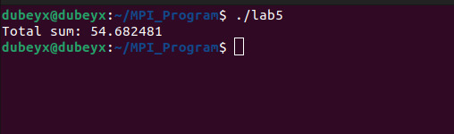

Experiment 6

Write a c program with openmp to implement loop work sharing

#include <stdio.h>

#include <omp.h>

#define N 1000000

int main() {

int i, sum = 0;

int a[N];

// Initialize array

for (i = 0; i < N; i++) {

a[i] = i;

}

// Use OpenMP to parallelize loop

#pragma omp parallel for reduction(+:sum)

for (i = 0; i < N; i++) {

sum += a[i];

}

printf("Sum = %d\n", sum);

return 0;

}

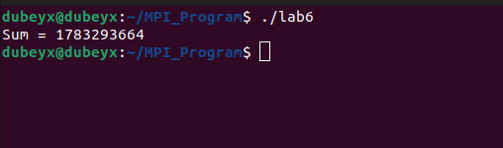

**Experiment 7**

Write a c program with openmp to implement section work sharing

#include <stdio.h>

#include <omp.h>

void section1() {

printf("Executing section 1 on thread %d\n", omp_get_thread_num());

}

void section2() {

printf("Executing section 2 on thread %d\n", omp_get_thread_num());

}

int main() {

// Use OpenMP to parallelize sections

#pragma omp parallel sections

{

#pragma omp section

{

section1();

}

#pragma omp section

{

section2();

}

}

return 0;

}

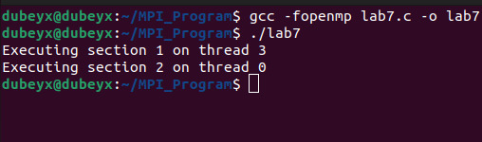

**Experiment 8**

Write a c program to illlustrate process synchronization and collective data movement

#include <stdio.h>

#include <stdlib.h>

#include <mpi.h>

#define ARRAY_SIZE 10

int main(int argc, char** argv) {

int rank, size;

int array[ARRAY_SIZE];

int sum = 0;

MPI_Init(&argc, &argv);

MPI_Comm_rank(MPI_COMM_WORLD, &rank);

MPI_Comm_size(MPI_COMM_WORLD, &size);

if (rank == 0) {

// initialize array

for (int i = 0; i < ARRAY_SIZE; i++) {

array[i] = i + 1;

}

}

// Synchronize all processes

MPI_Barrier(MPI_COMM_WORLD);

// Scatter the array across all processes

MPI_Scatter(array, ARRAY_SIZE/size, MPI_INT, array, ARRAY_SIZE/size, MPI_INT, 0, MPI_COMM_WORLD);

// Compute the sum of the local portion of the array

for (int i = 0; i < ARRAY_SIZE/size; i++) {

sum += array[i];

}

// Compute the global sum of the array

int global_sum;

MPI_Reduce(&sum, &global_sum, 1, MPI_INT, MPI_SUM, 0, MPI_COMM_WORLD);

if (rank == 0) {

printf("Global sum: %d\n", global_sum);

}

MPI_Finalize();

return 0;

}

